**Setting up your environment**

To setup R and R-studio you will first need to identify the Operating System (OS) that your machine is running. The OS will likely be one of the following:

* Windows Vista 7/8/10
* A Linux distribution such as Ubuntu
* Mac OS X

Navigate and download RStudio Desktop:

* <https://www.rstudio.com/products/rstudio/download/> at the bottom of the page it will list several releases based on the OS.
* Or visit <https://www.rstudio.com> and locate the download page for RStudio Desktop   
  (We used 1.0.136 at the time of writing)

Use the default options during the installation.

Next, navigate and download R

* https://cran.rstudio.com/ on the landing page there should be options to download the latest R release. You should download the base version

(We used 3.3.2 at the time of writing)

Again, use the default installation options.

Now launch RStudio and you should see the following (or similar) user interface:

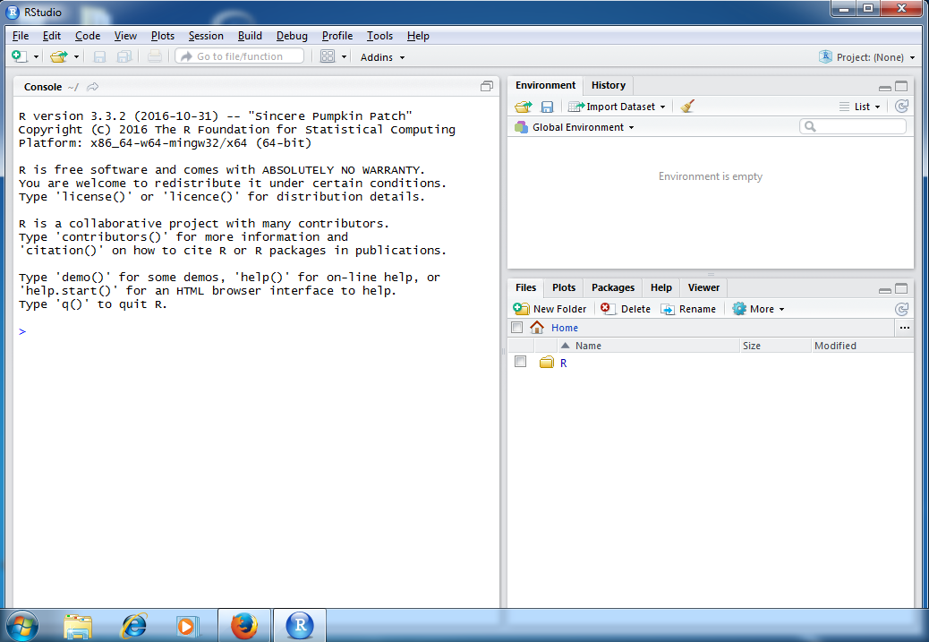

Congratulations! You have now setup your environment.